THERE IS NO DEEP STATE

The problem in Washington is not a conspiracy against the President; it’s the President himself.
[And if you believe that, I’ve got a bridge I want to sell you! -FNC]
The problem in Washington is not a conspiracy against the President; it’s the President himself.

By David Remnick

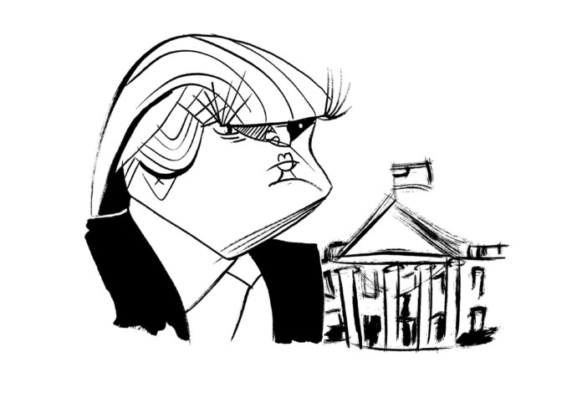Illustration by Tom Bachtell

[ On Mon, Mar 20, 2017, at 4:47 PM, Rusty said:
“Read this story about the Deep State….It doesn’t exist. It’s just a paranoid delusion and we know that Trump is paranoid and full of delusions…..But you guys are smarter than to believe this paranoid crap…..i-hope...
http://www.newyorker.com/magazine/2017/03/20/there-is-no-deep-state “ ]

[Rusty, the fact that you recommend this piece helps me to understand why you and I are having a hard time
Agreeing on the notion of the Deep State.

I made a few comments below.

Mainly, though, this article is about an attempt to get rid of Donald Trump. It is probably not, IMHO, the best place to look to understand how the term / meme “Deep State” is being used today.
The reason the term “Deep State” is being grabbed and used to “explain” events in 2016/2017 is that Hillary and Donald represented two alternatives where relatively large number of deep state components feel their objectives threatened. The march toward a unipolar great power (the USA, of course) and away from a world of nation-states, for example.
Politics is relatively out in the open and understandable, if for no other reason than the essential activity of reflecting the citizens’ policy desires in the working government involves a lot of open communication.
A Deep State, on the other hand, has long-lasting essentially permanent, components.
- the Israel Lobby,
- the Bilderbergers,
- Great Britain’s Ruskin -> Rhodes -> Milner sequence
- New World Order / One World Government advocates,
- lifetime government employees,
- the militaryindustrial complex,
- big science,
- The OSS / OPC / ESF / CIA,
- the Zionists
- perhaps the Rothschilds and the central banks (almost all of them, Libya’s and Iran’s being exceptions) controlled by them.
A component is not present merely because of secret “black ops” activities as long as these activities pursue agreed policies of the state.
These components
- are long-lasting (multi – decadal) -- essentially permanent.
- have policy objectives substantially separate from those of the State.
- The component’s policy objectives are occasionally written but usually not.
- These policy objectives are by definition “foreign” and represent the objectives of an entity other than the State.
- Naturally the policy objectives are almost never available for open discussion.

Assertion of the existence of any of these components of the Deep State is naturally described as a conspiracy theory about a component that “does not exist”) – particularly by opinion writers for major news chains and think tank “contributors” whose livelihood can be traced back to the component.))

IMHO, the reason the term “Deep State” is floating around in 2016/2017 is that Hillary and Donald represented two alternatives where a number of these components see their policy objectives threatened.

]

One evening in 1970, a young Navy lieutenant found himself outside the White House Situation Room with a parcel of sensitive Pentagon documents, waiting for someone to sign for them. He sat down beside a man in late middle age, who wore a dark suit and an unsmiling expression. “There was nothing overbearing in his attentiveness,” the officer recalled years later. “But his eyes were darting in a kind of gentlemanly surveillance.”
The two men fell into conversation. The lieutenant mentioned that he had been taking graduate courses at George Washington University. The older man said that he had gone to law school at G.W. at night. Now he was at the Federal Bureau of Investigation, working under J. Edgar Hoover. He encouraged the young man to pursue only employment that interested him, and, shortly afterward, the officer applied for a job as a reporter at the Washington Post. He flunked the tryout and went to work instead for a suburban weekly. But he kept in touch with his friend, seeing him as a kind of career counsellor and, not without guile, as a potential source. Soon, the F.B.I. man confided in the reporter, telling him that he believed that the Nixon Administration was corrupt, paranoid, and trying to infringe on the independence of the Bureau.
In the summer of 1971, both men were promoted, one to the No. 3 job at the F.B.I., the other to the metropolitan staff of the Post. Within a year, their friendship became the most important reporter-source relationship in modern history. The reporter was Bob Woodward, who, with Carl Bernstein, led the coverage of the Watergate scandal and the fall of Richard Nixon. The F.B.I. man was Mark Felt, who, until he was in his nineties and revealed himself as Woodward’s source, was known to the world only as Deep Throat.
Was Deep Throat part of an American Deep State? [Probably not -FNC]
Some of Donald Trump’s most ardent supporters (and, in a different, cautionary spirit, a few people on the left) have taken to using “the Deep State” to describe a nexus of institutions—the intelligence agencies, the military, powerful financial interests, Silicon Valley, various federal bureaucracies—that, they believe, are conspiring to smear and stymie a President and bring him low.
[The following bit of history is generally accurate, AFAIK. –FNC]

“Deep State” comes from the Turkish derin devlet, a clandestine network, including military and intelligence officers, along with civilian allies, whose mission was to protect the secular order established, in 1923, by the father figure of post-Ottoman Turkey, Mustafa Kemal Atatürk. It was behind at least four coups, and it surveilled and murdered reporters, dissidents, Communists, Kurds, and Islamists. The Deep State takes a similar form in Pakistan, with its powerful intelligence service, the I.S.I., and in Egypt, where the military establishment is tied to some of the largest business interests in the country. [End history. Now, completely switching gears, back to 2017 USA politics.]
One day earlier this month in Palm Beach, just after 6 a.m., the President went on a vengeful Twitter binge. Trump reads little but has declared himself “the Ernest Hemingway of a hundred and forty characters,” and that morning he levelled what the Times rightly called “one of the most consequential accusations made by one president against another in American history.” With no evidence, save the ravings of the talk-radio host Mark Levin and an account, in Breitbart News, of Levin’s charges of a “silent coup,” Trump accused President Obama of tapping his “wires” at Trump Tower. He compared the unsubstantiated offense to “McCarthyism” and “Nixon/Watergate.”
By now, Trump’s tactics are familiar. Schooled by Roy Cohn, Joseph McCarthy’s protégé, in the dark arts of rage, deflection, insult, and conspiracy-mongering, Trump ignited his political career with “birtherism,” and he has kept close by his side Steve Bannon, formerly of Breitbart, who traffics in tinfoil-hat theories of race, immigration, and foreign affairs. Together, they have artfully hijacked the notion of “fake news,” turning it around as a weapon of insult, diversion, division, and attack.
[Now we switch back for a (questionable) paragraph about “US Deep State”.]
One does not have to be ignorant of the C.I.A.’s abuses—or of history, in general—to reject the idea of an American Deep State. [True. But out of place. This article is an attack on Trump, not an essay on how extensive the US Deep State is.]
Previous Presidents have felt resistance, or worse, from elements in the federal bureaucracies: Eisenhower warned of the “military-industrial complex”; L.B.J. felt pressure from the Pentagon; Obama’s Syria policy was rebuked by the State Department through its “dissent channel.” But to use the term as it is used in Turkey, Pakistan, or Egypt is to assume that all these institutions constitute part of a subterranean web of common and nefarious purpose. The reason that Trump is so eager to take a conspiratorial view of everything from the C.I.A. to CNN is that an astonishing array of individuals have spoken out or acted against him. Above all, he is infuriated that intelligence and investigative services have been looking into possible Russian connections to him, his advisers, his campaign, and his financial interests.
Bannon and Trump, according to the Post, refer to the Deep State only in private, but their surrogates feel no hesitation about doing so openly. “We are talking about the emergence of a Deep State led by Barack Obama, and that is something we should prevent,” Representative Steve King, of Iowa, said. “The person who understands this best is Steve Bannon, and I would think that he’s advocating to make some moves to fix it.”
Trump and Bannon would undoubtedly have called Deep Throat glaring evidence of an American Deep State. [The previous sentence is speculative bullshit.]
Felt was a Hoover loyalist; he oversaw the F.B.I.’s pursuit of radical groups like the Weather Underground and instituted illegal searches, known as “black-bag jobs.” Yet he was deeply offended that the President and his top aides ran what constituted a criminal operation out of the White House, and he risked everything to guide Woodward. The level of risk became clear in October, 1972, when Nixon’s aide H. R. Haldeman told him that Felt was the likely source. “Now, why the hell would he do that?” Nixon said. “Is he Catholic?” “Jewish,” Haldeman replied. “Christ, [they] put a Jew in there,” Nixon said. “That could explain it, too.” (It didn’t, quite. Felt was not Jewish.)
The problem in Washington is not a Deep State [Maybe, but out of place. This article is an attack on Trump, not an essay arguing that any deep state in the USA is minimal.]
the problem is a shallow man—an untruthful, vain, vindictive, alarmingly erratic President.

In order to pass fair and proper judgment, the public deserves a full airing of everything from Trump’s tax returns and business entanglements to an accounting of whether he has been, in some way, compromised. Journalists can, and will, do a lot. But the courts, law enforcement, and Congress—without fear or favor—are responsible for such an investigation. Only if government officials take to heart their designation as “public servants” will justice prevail. ♦

David Remnick has been editor of The New Yorker since 1998 and a staff writer since 1992. He is the author of “The Bridge: The Life and Rise of Barack Obama.”

- More
This article appears in other versions of the March 20, 2017, issue, with the headline “First as Tragedy.”

